+++++++++++++++++++++++++++++++++++++++++++

Multibranch pipeline

-------------------------

When developer creates code for multiple functionalities, he will generally do that on separate branches.

Every branch will contains specific code related to one functionality.

Along with the code, the developer will also create separate jenkins file for every branch.

This jenkins file will contain the stages of CI-CD, that should be performed on that branch.

All these branches along with jenkins file will be uploaded by into the github repository.

We should create a jenkins job, which will work on these branches parallely and execute the steps present in different jenkins files.

Steps performed by the developer

------------------------------------

$ mkdir multibranch

$ cd multibranch

Download the files of maven repository

$ git clone https://github.com/sunildevops77/maven.git

Remove the hidden folder

$ cd maven

$ rm -rf .git ( Will break the link to maven repository )

$ git init ( create a new working directory )

$ git status

$ git add .

$ git commit -m "a"

$ git log

Developer creates branch

$ git checkout -b loans

$ git log

$ git checkout master

$ ls

Make changes to the jenkins file

$ vim Jenkinsfile

( Lets make it only two stages )

node('built-in')

{

stage('Continuous Download_Master')

{

git 'https://github.com/sunildevops77/maven.git'

}

stage('Continuous Build_master')

{

sh label: '', script: 'mvn package'

}

}

:wq

(Observation, we have done the changes in master branch )

$ git add .

$ git commit -m "b"

$ git checkout loans

$ ls

$ vim Jenkinsfile

(Lets make it only two stages)

node('built-in')

{

stage('Continuous Download_Loans')

{

git 'https://github.com/sunildevops77/maven.git'

}

stage('Continuous Build_Loans')

{

sh label: '', script: 'mvn package'

}

}

:wq

$ git add .

$ git commit -m "c"

Observe (master branch is having jenkins file.

Loans branch is having jenkins file )

$ git checkout master

Create new repository in github

--------------------------------------

Repository name - Jenkins_multiBranch24

$ git remote add origin https://github.com/lakshmi1908/Jenkins_multiBranch21.git

$ git push -u origin –all (as we want to push all branches)

(Check the remote repository)

+++This is developers activity+++++++++

Login to jenkins

New item -- MultiBranchPipeline

Select multibranch Pipeline

Branch Sources

Add source

Git

Project Repository -- <https://github.com/sunildevops77/Jenkins_multiBranch24.git>

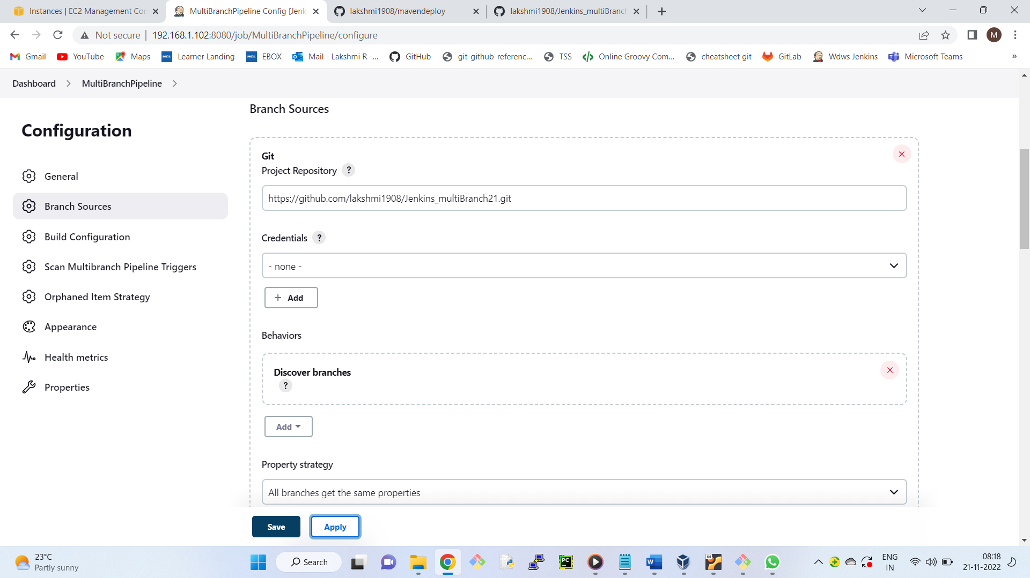

Scan multibranch pipeline triggers

Check periodically if not otherwise

Interval - 1 minute

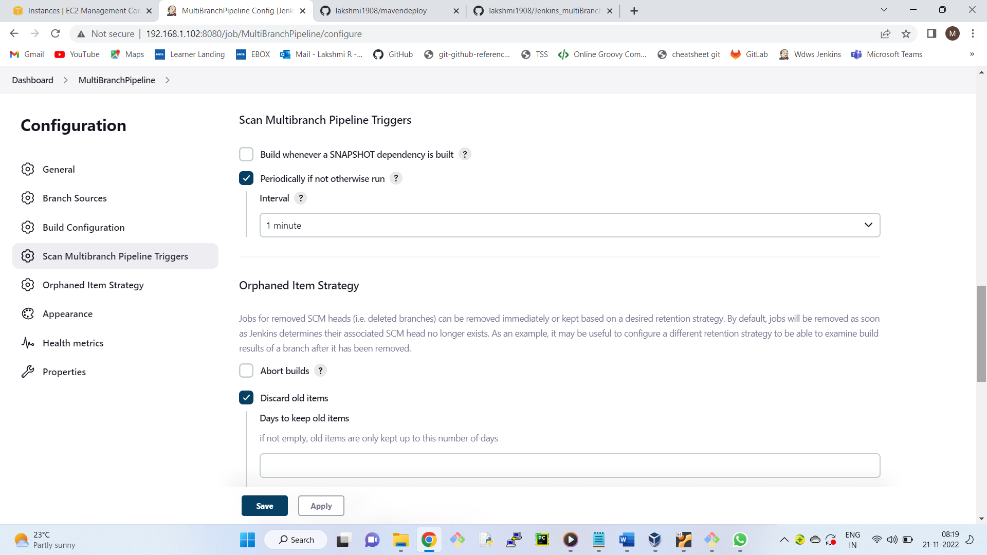

Apply --- Save

By this time it will be started.

This job will check github every minute.

Select multibranch pipeline

You will find two branches

Select loans , we can see two stages

Select master , we can see two stages

Lets say, developer will make changes and push to the repostitory

$ vim README.md ( Make some changes )

$ git add .

$ git commit -m "d"

Similarly, lets repeat in loans branch

$ git checkout loans

$ vim README.md ( Make some changes )

$ git add .

$ git commit -m "e"

$ git checkout master

To push all the branches

$ git push -u origin --all

Observation: Job will start automatically.



